**Final Capstone Project:**

**Algorithmic Stock Trading System**

Group 6: Nathan Metheny, Javon Kitson, Adam Graves

University of San Diego

AAI-590: Capstone Project

Professor: Anna Marbut

April 15, 2024

**Introduction**

Our objective is to demonstrate the application of Deep Reinforcement Learning (DRL) in the domain of algorithmic stock trading. By leveraging advanced machine learning techniques, we aim to develop a system capable of taking a range of input matrix and then making informed trading decisions autonomously. This involves the creation of a model that can analyze investors portfolio data, historical stock data, understand market trends, and execute trades with the goal of maximizing returns. The demonstration will cover the setup, training, and evaluation of the DRL model, showcasing its potential to outperform traditional trading strategies.

In addition to the technical implementation, we will explore the theoretical foundations of reinforcement learning and its suitability for financial markets. This includes discussing the challenges of applying DRL in a highly volatile environment, such as stock trading, and the strategies used to mitigate these risks. Our demonstration aims to provide a comprehensive overview of how deep reinforcement learning can be utilized to innovate in the field of stock trading, offering insights into both its capabilities and limitations.

**Dataset Summary**

The dataset used in this Deep Reinforcement Learning Stock Trading is a paid a licensed dataset from Firstrate Data.

Data Information:

| **FREQUENCY** | **DATE RANGE** | **NUMBER OF TICKERS** |  |
| --- | --- | --- | --- |
| 1-minute, 5-minute, 30-minute, 1-hour 1-day | Jan 2005 - Mar 2024 (see below dates for each ticker) | 10120 Tickers |  |

The bundle comprises 1-minute/5-min/30-min/1-hour intraday data as well as daily end-of-day data for:  
7531  most liquid US stocks (includes all active Russell 3000, S&P500, Nasdaq 100, and DJI stocks)

* 2527  most liquid ETFs
* 460 delisted stocks

Both stocks and ETFs are adjusted for splits/dividends, out-of-hours trades are included.

Demonstration comprises historical stock data, including open, high, low, close prices, and volume for a selection of stocks over a specified period. This data is essential for training our DRL model, allowing it to learn and make predictions about future stock movements based on past trends. The dataset includes a diverse range of stocks from various sectors, ensuring a comprehensive learning experience for the model. The period covered by the dataset is from [start_date] to [end_date], encompassing 10,120 stocks. We have structured the system to train and trade on a subset of the dataset that corresponds with the predefined groupings within the stock market (SP 100, DOW 30, NAS 100, etc.). This rich dataset serves as the foundation for our demonstration, enabling the DRL model to simulate trading strategies and evaluate their performance in a controlled, paper trading environment. To enhance the predictive capabilities of our Deep Reinforcement Learning (DRL) model and provide a more nuanced understanding of the stock market dynamics, we augment select variables within our dataset. This augmentation process involves creating new variables or modifying existing ones to include derived metrics, such as moving averages, volatility indicators, and technical analysis signals. These augmented variables offer additional insights into market trends, momentum, and potential reversal points, which are crucial for making informed trading decisions.

**Background Information**

Previous popular algorithmic stock trading systems have been based on the ability to predict the trading price of the stock on a day-to-day basis. As they advanced, they had the ability to go deeper into the prediction at a certain point of time. The foundation of this was the ability to trade on the condition of the limit price entered.

With our system we aim to alleviate the need to trade by a limit price and build a better algorithm that will rely on our DRL AI model and have the ability to trade at market price and still be successful.

To enhance the predictive capabilities of our Deep Reinforcement Learning (DRL) model and provide a more nuanced understanding of the stock market dynamics, we augment select variables within our dataset. We break this down into two sets of logical variables; one is the trading variables and the second is the portfolio variables. This augmentation process involves creating new variables or modifying existing ones to include derived metrics, such as moving averages, volatility indicators, and technical analysis signals, trading strategies, and constraints. These augmented variables offer additional insights into market trends, momentum, strategies, and potential reversal points, which are crucial for making informed trading decisions.

By incorporating these augmented variables, our DRL model can analyze not only the raw historical stock data but also the underlying patterns and relationships between different market indicators and alignment to the investor’s strategies. This enriched dataset allows the model to capture a more comprehensive picture of the market, leading to improved accuracy in predicting future stock movements and optimizing trading strategies. The augmentation process is carefully designed to ensure that the new variables are relevant, non-redundant, and contribute positively to the model's learning process, thereby enhancing its overall performance in the stock trading demonstration.

**Experimental Methods**

High Level Diagram Flow:

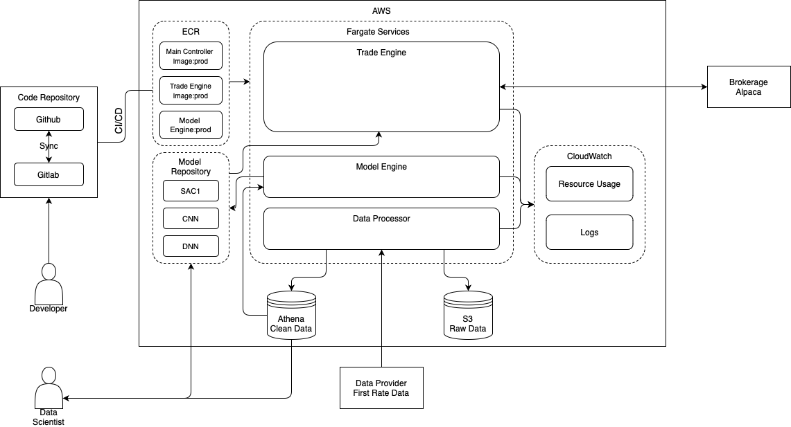

Diagram Of Trading Flow:

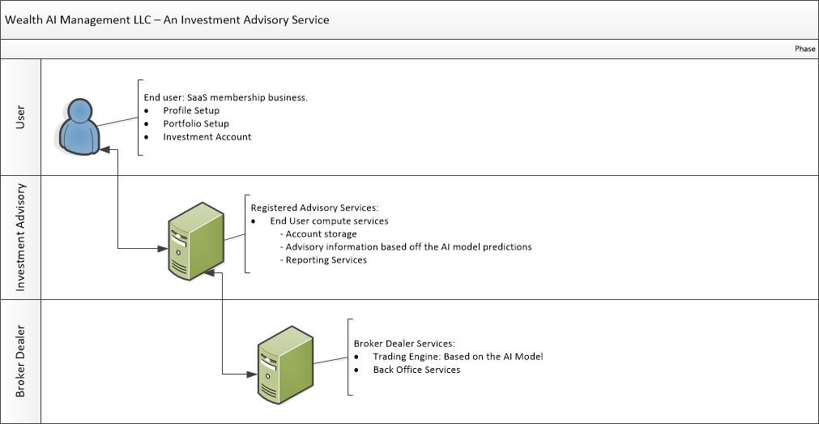

Diagram of Portfolio and Account Management

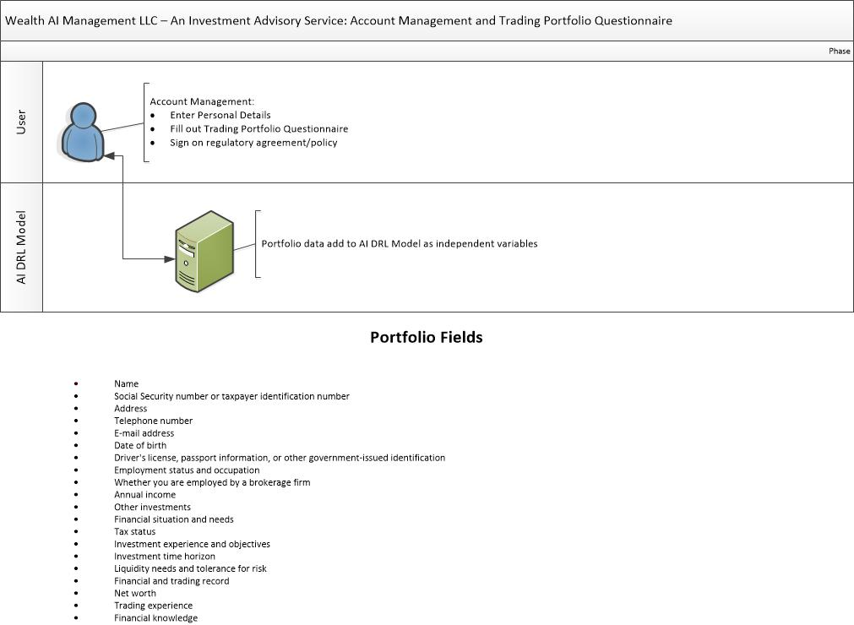

This section of your final report should describe the model architecture choices that you have  
made, as well as the training and optimization procedures that you follow. The reader should be  
able to answer the following questions:  
- What type of machine learning model(s) are you using?  
- What are the notable architectural design choices that you have made and why? E.g.,  
number of nodes, hidden layers, activation functions, etc.  
- What is your model training procedure? E.g., How did you split your data? How many  
epochs/iterations did you use during training? What was your batch size? What loss  
function/training metrics were used?  
- How did you optimize your model? E.g., Which hyperparameters and/or architectural  
elements did you adjust

**Results/Conclusion**

This section of your final report should describe how your model performed and provide  
evidence for how your work did/did not support your experimental hypothesis or solve your  
chosen problem. The reader should be able to answer the following questions:  
- How effective was your machine learning model at learning the task? e.g. Did the model  
overfit/underfit the training data? What does the training accuracy/loss curve look like for  
your model?  
- If your project is focused on answering a research question, what evidence do you have  
to support or disprove your hypothesis?  
- If your project is focused on solving a problem, how will your model performance affect  
the application of your model to that problem?  
- Did your model training or performance bring about any unexpected results?  
- If you were to continue this project, what would your next steps be? e.g., Would you  
continue to optimize your model or try other model architectures? Would you change or  
expand the data used in your model? What steps need to be taken to “productionize”  
your model

**References**

ffffffffffffff